|  |
| --- |
| OBJECTIVES |
| 1. What is Software? 2. What is Application software? 3. Type of Application Software? 4. Features of Application Software? |

PROCESDURE

* Task 1: **What is Software?**

Software is the collection of data, programs, procedures, routines and instructions that tell a computer or electronic device how to run, work and execute specific tasks. This is in contrast to hardware, which is the physical system and components that perform the work.

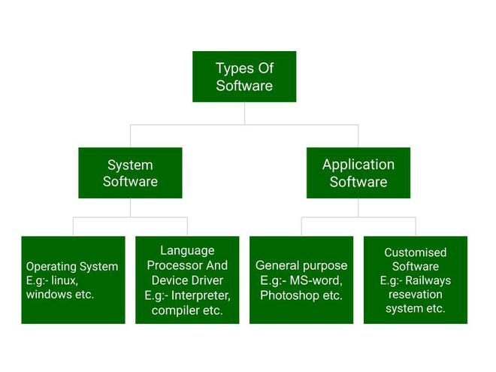

* Task 2: **What is Application software?**

Software that performs special functions or provides functions that are much more than the basic operation of the computer is known as application software. Or in other words, application software is designed to perform a specific task for end-users. It is a product or a program that is designed only to fulfill end-users’ requirements. It includes word processors, spreadsheets, database management, inventory, payroll programs, etc.

Task 3: Type of Application Software?

There are different types of application software and those are:

* **General Purpose Software**: This type of application software is used for a variety of tasks and it is not limited to performing a specific task only. For example, MS-Word, MS-Excel, PowerPoint, etc.
* **Customized Software:** This type of application software is used or designed to perform specific tasks or functions or designed for specific organizations. For example, railway reservation system, airline reservation system, invoice management system, etc.

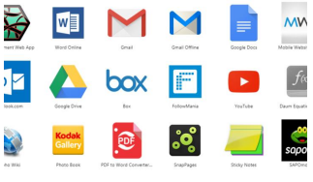

* **Utility Software**: This type of application software is used to support the computer infrastructure. It is designed to analyze, configure, optimize and maintains the system, and take care of its requirements as well. For example, antivirus, disk fragmented, memory tester, disk repair, disk cleaners, registry cleaners, disk space analyzer, etc.
* Task 4: Features of Application Software.

Let us discuss some of the features of Application Software:

* An important feature of application software is it performs more specialized tasks like word processing, spreadsheets, email, etc.
* 2. Mostly, the size of the software is big, so it requires more storage space.
* 3. Application software is more interactive for the users, so it is easy to use and design.
* The application software is easy to design and understand.
* 5. Application software is written in a high-level language in general